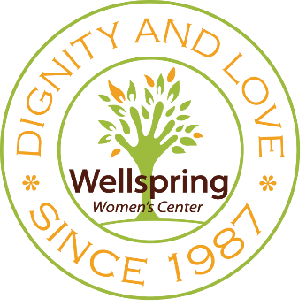
Thank you for thinking of Wellspring in your future! Your gift will improve lives of women and children for years to come.
Legacy Gift Intent
3414 4th Avenue
P.O. Box 5728
Sacramento, CA 95817
PLEASE PRINT NEATLY
MY INFORMATION
Full name _________________________________________________________________________________
Spouse (optional) ___________________________________________________________________________
Home address ______________________________________________________________________________
City _________________________________________ State __________ Zip ___________________________
Preferred phone (home/cell/work) _____________________________________________________________
Email _____________________________________________________________________________________
MY GIFT
This is to inform you that I/we have included a gift to Wellspring Women’s Center in my/our estate plan.
This gift has been designated through a:

- Bequest
- Charitable gift annuity
- IRA
- Life insurance policy
- Retained life estate
- Other: ____________________
The value of this gift falls in the following range:

- $500 – $1,000
- $1,001 – $5,000
- $5,001 – $10,000
- $10,001 – $25,000
- $25,001 – $50,000
- $50,001 – $100,000
- $100,001 – $250,000
- $250,001 – $500,000
- Other: ______________

Please provide us with any additional details you’d like to share about your gift:
__________________________________________________________________________________________
__________________________________________________________________________________________
__________________________________________________________________________________________

Signature ________________________________________________________________ Date _____________

